**MINI PROJECT REPORT**

**On**

**“SMART HOME”**

**Submitted by**

**Punya prakash sharma**

**( 171500244)**

**Pranshu gupta**

**(171500228)**

**Himanshu Sharma**

**(171500137)**

**Vishal Singh Rajput**

**(171500387)**

Department of Computer Engineering & Applications

**Institute of Engineering & Technology**



**GLA University**

**ACKNOWLEDGEMENT**

**W**e are using this opportunity to express our gratitude to everyone who supported us throughout the course of this project, we are thankful for their aspiring guidance, invaluably constructive criticism and friendly advice during the project work. We are sincerely grateful to them for sharing their truthful and illuminating views on a number of issues related to the project.

We are thankful to “**Dr. Manoj Varshney**” for his support and guidance throughout the project.

We express our warm thanks to “**Mr. Ajitesh Kumar**” for providing laboratory facilities, thereby allowing us to complete our project on time.

Nevertheless, we express our gratitude toward our families and colleagues for their kind co-operation and encouragement which helped us in completion of this project.

**Department of computer Engineering and Applications**

**GLA University, Mathura**

**17 km. Stone NH#2, Mathura-Delhi Road, P.O. – Chaumuha,**

**Mathura – 281406**



**Declaration**

I hereby declare that the work which is being presented in mini project “**SMART HOME”,** is an authentic record of my own work carried under the supervision of “**GLA UNIVERSITY.**

**Signature of Candidates:**

**Pranshu Gupta**

**Vishal Singh**

**Himanshu Sharma**

**Punya Sharma**

**Name of Candidates:**

**Pranshu Gupta** (171500228)

**Vishal Singh** (171500387)

**Himanshu Sharma** (171500137)

**Punya Prakash Sharma** (171500244)

**Course:** B.TECH

**Year:** Third Year

**Semester:** 6th

**INTRODUCTION**

While the cost of living is going up, there is a growing focus to involve technology to lower those prices. With this in mind the Smart Home project allows the user to build and maintain a house that is smart enough to keep energy levels down while providing more automated applications. A smart home will take advantage of its environment and allow seamless control whether the user is present or away. With a home that has this advantage, you can know that your home is performing at its best in energy performance. A low cost and efficient smart home system is presented here. This system has two main modules: the hardware interface module and the software communication module. At the heart of this system is the NodeMCU microcontroller which is also capable of functioning as a micro web server and the interface for all the hardware modules. All communication and controls in this system pass through the microcontroller. The smart home system offers feature such as environmental monitoring using the temperature, humidity, gas and smoke sensors. It also offers switching functionalities to control lighting,fans/air conditioners, and other home appliances connected to the relay system. Another feature of this system is the intrusion detection which it offers using the motion sensor and all these can be controlled from the Android Smartphone app.

**SYSTEM ANALYSIS**

**INTRODUCTION:**

Analysis can be defined by breaking up of any whole so as to find out their nature, working functionalities etc. It defines design as to make preliminary sketches of; to sketch a pattern or outline for planning. To plan and carry out especially by artistic arrangement or in a skilful wall. System analysis and design can be characterized as a set of techniques and processes, a community of interests, a culture and intellectual orientation.

The various tasks in system analysis phase including the following:

● Understanding Application

● Project Planning

● Project Scheduling

● Supervising, Installing, Maintaining the system

**EXISTING SYSTEM:**

The Existing system based on with the GSM Module & Bluetooth Module only. The recent developments in technology which permit the Use of Bluetooth and Wi-Fi have enabled different devices to have capabilities of connecting with each other. In this system we can control our all electronic equipment through our cell phone but this system does not has the smart sense. We can produce the smart sense by using various sensors. Existing systems are employed with wired connections. Wired system requires proper planning and construction works for efficient and clean design. It is the reason wireless communications are replacing the wired ones. Because of the wired connections the communication range of components are also very less.

**PROPOSED SYSTEM:**

To overcome the drawbacks of the existing system, the proposed system has been evolved. This project aims to reduce the paper work and saving time to generate accurate results.Our proposed system is a NODEMCU based home automation done with NODEMCU controlled via android app. This system deals with the safety in home and smart home technologies which will be cost efficient. NodeMCU can sense the surroundings by receiving input signal from a variety of sensors and can affect its environment via actuators. The Passive Infra-Red (PIR) sensors allow one to sense motion, almost always and are used to detect whether a human has moved in or out of the sensors range. The PIR sensor is a pyroelectric device that detects motion by measuring changes in the infrared level emitted by surrounding objects. Existing system consist of servo moters for opening and closing of doors. System consist of Rain sensor for detection of rain to which all the servos are also communicating. System also consist of DHT11 sensor for monitoring of temperature and humidity and MQ135 sensor for monitoring of the air quality.

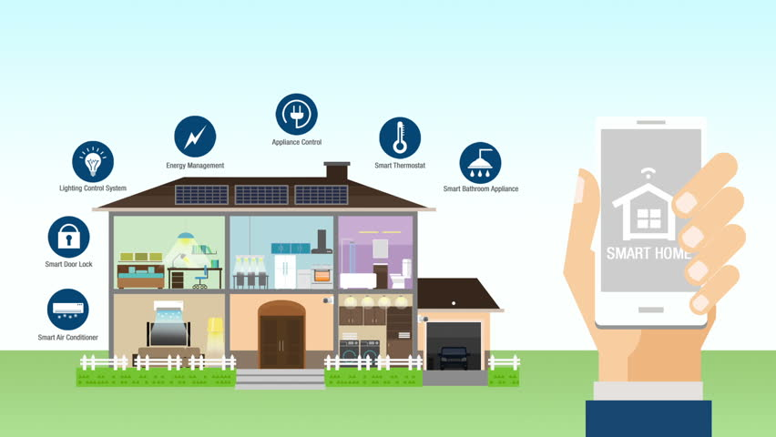

**FEASIBILITY STUDY:**

Feasibility study begins once the goals are defined. It starts by generating board possible solutions, which are possible to give an indication of what is new system should look like. That is where creativity and imagination are used. Analysts must think up the new ways of doing things generating new ideas. There is no need to go into the detailed system operation yet. The solution should provide enough information to make reasonable estimates about project cost and give user an indication of how the new system will fit into the organization. Feasibility of a new system means ensuring that the new system, which we’re going to implement is efficient and affordable. There are various types of feasibility that should be taken into consideration:

● Economical feasibility

● Technical feasibility

● Operational feasibility

**SYSTEM SPECIFICATION**

**SOFTWARE SPECIFICATION:**

● Technology Implemented:IOT

● Language Used: Embedded C

●User Interface: BLYNK Android Application

**HARDWARE SPECIFICATION:**

● NODEMCU

● Connecting Wires

● Power Source

● Resisters

● Bread Board

● PIR Sensor

● Rain Sensor

● RGB LED

● Servo Moters

● Temperature and Humidity Sensor

● Air Quality Sensor

**SYSTEM DESCRIPTION**

**SOFTWARE DESCRIPTION:**

●**ARDUINO IDE:**

The Arduino Integrated Development Environment (IDE) is a cross-platform application (for Windows, macOS, Linux) that is written in functions from C and C++. It is used to write and upload programs to Arduino compatible boards, but also, with the help of 3rd party cores, other vendor development boards.

●**EMBEDDED C:**

Embedded c is set of language extensions for the C programming language by the C Standards Committee to address commonality issues that exist between C extensions for different embedded systems.

●**BLYNK:**

Blynk is a Platform with IOS and Android apps to control Arduino, Raspberry Pi and the likes over the internet. It provides its cloud for data handling. It is a digital dashboard where you can build a graphic interface for your project by simply dragging and dropping widgets.

**HARDWARE DESCRIPTION:**

●**NODEMCU:**

NodeMCU is an open-source firmware and development kit that helps you to prototype or build IoT product. It includes firmware which runs on the ESP8266 Wi-Fi SoC from Espressif Systems, and hardware which is based on the ESP-12 module. The firmware uses the Lua scripting language. It is based on the eLua project, and built on the Espressif Non-OS SDK for ESP8266. MCU stands for MicroController Unit - which really means it is a computer on a single chip. A microcontroller contains one or more CPUs (processor cores) along with memory and programmable input/output peripherals. They are used to automate automobile engine control, implantable medical devices, remote controls, office machines, appliances, power tools, toys etc. Operating voltage of NodeMCU is 5.5 volt.

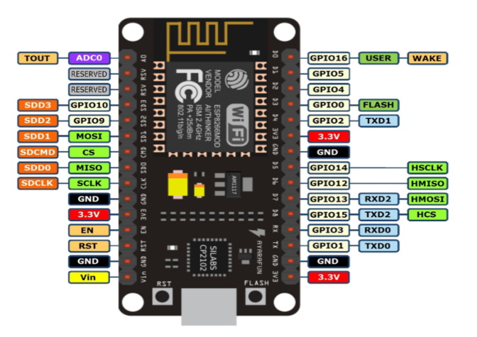

●**PIR SENSOR:**

A passive infrared sensor (PIR sensor) is an electronic [sensor](https://en.wikipedia.org/wiki/Sensor" \o "Sensor) that measures [infrared](https://en.wikipedia.org/wiki/Infrared" \o "Infrared) (IR) light radiating from objects in its field of view. They are most often used in PIR-based [motion detectors](https://en.wikipedia.org/wiki/Motion_detector" \o "Motion detector). PIR sensors are commonly used in security alarms and automatic lighting applications. PIR sensors detect general movement, but do not give information on who or what moved. Itdetects motion by observing the infrared light radiation coming from the objects. When it detects any type of motion, it generates the 3.3 volts of output voltage. It consist two pins for adjusting its detection range and delay. It works at the operating voltage of 5 volts. It can detect up to seven meters and its minimum detection range is 2 meters. It consist of 3 pins: VCC, OUT, GND. Resolution of PIR sensor is 120 degree. It can operate between -12 degrees Celsius to +80 degrees Celsius.

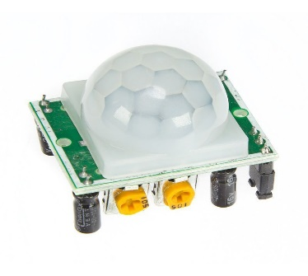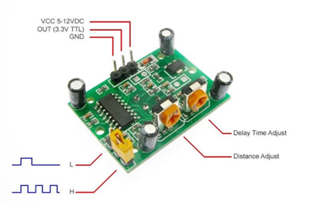

●**RAIN SENSOR:**

A rain sensor or rain switch is a switching device activated by rainfall. There are two main applications for rain sensors. The first is a [water conservation](https://en.wikipedia.org/wiki/Water_conservation" \o "Water conservation) device connected to an automatic [irrigation](https://en.wikipedia.org/wiki/Irrigation" \o "Irrigation) system that causes the system to shut down in the event of rainfall. The second is a device used to protect the interior of an automobile from rain and to support the automatic mode of [windscreen wipers](https://en.wikipedia.org/wiki/Windscreen_wipers" \o "Windscreen wipers). Operating voltage of rain sensor is 5 volts.

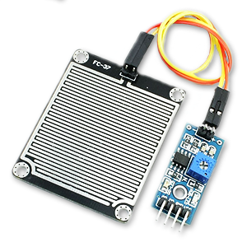

●**TEMPERATURE AND HUMIDITY SENSOR:**

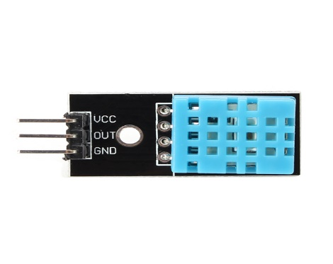The DHT11 is a basic, low-cost digital temperature and humidity sensor. It uses a capacitive humidity sensor and a thermistor to measure the surrounding air, and spits out a digital signal on the data pin (no analog input pins needed). It’s fairly simple to use, but requires careful timing to grab data. The only real downside of this sensor is you can only get new data from it once every 2 seconds, so when using our library, sensor readings can be up to 2 seconds old. Operating voltage of DHT11 sensor is 5 volts and 3.3 volts. Accuracy of DHT11 is +-1 % and +- 1 degrees Celsius. Its temperature measuring range is 0 degrees Celsius to +50 degrees Celsius and its humidity measuring range is +20% to +90%.

● **AIR QUALITY SENSOR:**

MQ-135 is a basic air quality monitoring sensor. Operating voltage of MQ-135 sensor is 5 volts. It can detect NH3, NOx, alcohol, Benzene, smoke, CO2, etc. When it detects any of these gases it generates the 0 to 5 volts output voltage. It can be used as a digital or analog sensor the sensitivity of the digital pin can be varied using the potentiometer. It consist of four pins: VCC, GND, A0 and D0. A0 is for the analog output and D0 is for the digital output.

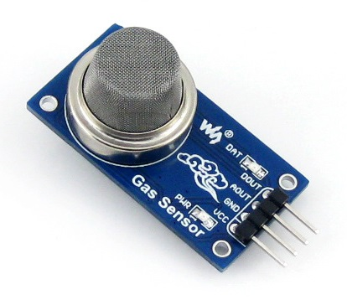

●**SERVO MOTOR:**

Servo motor is a rotatory motor. Which rotates at a certain angle between 0 degrees to 180 degrees. Servo motor does not rotate continuously. It is a three wire system two wires are for VCC and GND and third one is for control. Servo motor is an assembly of four, first one the gearing set. Second one is a positions sensor. Third one is a DC motor and last one is control circuit. Input voltage of servo motor is 5 volts.

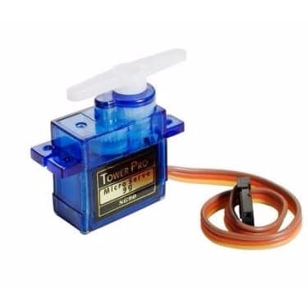

● **RGB LED:**

In this [red](https://en.wikipedia.org/wiki/Red" \o "Red), [green](https://en.wikipedia.org/wiki/Green" \o "Green) and [blue](https://en.wikipedia.org/wiki/Blue" \o "Blue) light are added together in various ways to reproduce a broad array of [colors](https://en.wikipedia.org/wiki/Color" \o "Color). This name comes from the initials of the three [additive primary colors](https://en.wikipedia.org/wiki/Additive_primary_colors" \o "Additive primary colors), red, green, and blue.

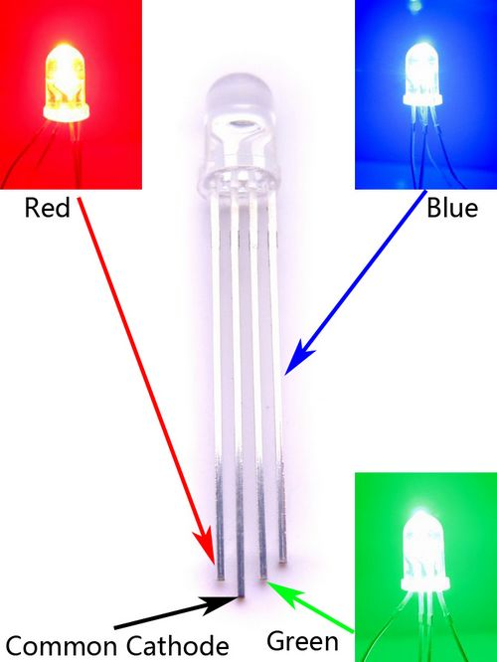

●**BREAD BOARD:**

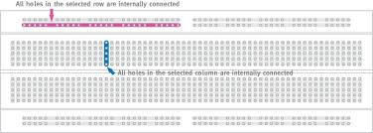It is a thin plastic board used to hold electronic components (transistors, resistors, chips, etc.) that are wired together. Used to develop prototypes of electronic circuit

**PROJECT DESCRIPTION**

●**PROBLEM DEFINITION:**

The project consists of developing and implementing a smart system that has the smart sense. The developed system will reduce the human work as well as save human time. In present time security is main concern to all. The developed system will have an alert system to prevent theft. Developed system can work continuously without any failure.

●**OVERVIEW OF THE PROJECT:**

The project is divided in several modules. All modules have the different functionality. All the modules are interconnected to each other and the whole system will be controlled via a smart phone.

●**MODULES DESCRIPTION:**

**1. SECURITY MODULE:**

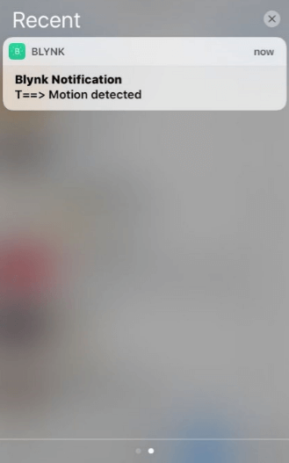In this module we have used passive infrared sensor for motion detection. We have implanted one PIR sensor on every wall just beside the windows. When any person tries to enter in the home through the windows, PIR sensor will send an alert notification to your phone.

**2. RAIN DETECTION MODULE:**

In this module we have used a rain detection sensor to detect the rainfall. It is placed on the rooftop. When it detects the rain, it automatically closes all the windows and also send a notification to your smart phone.

**3. LIGHTNING CONTROL MODULE:**

In this module RGB lights are used I order to provide lightning in the home. RGB lights have the several colors and through our phone we can change color of lights.

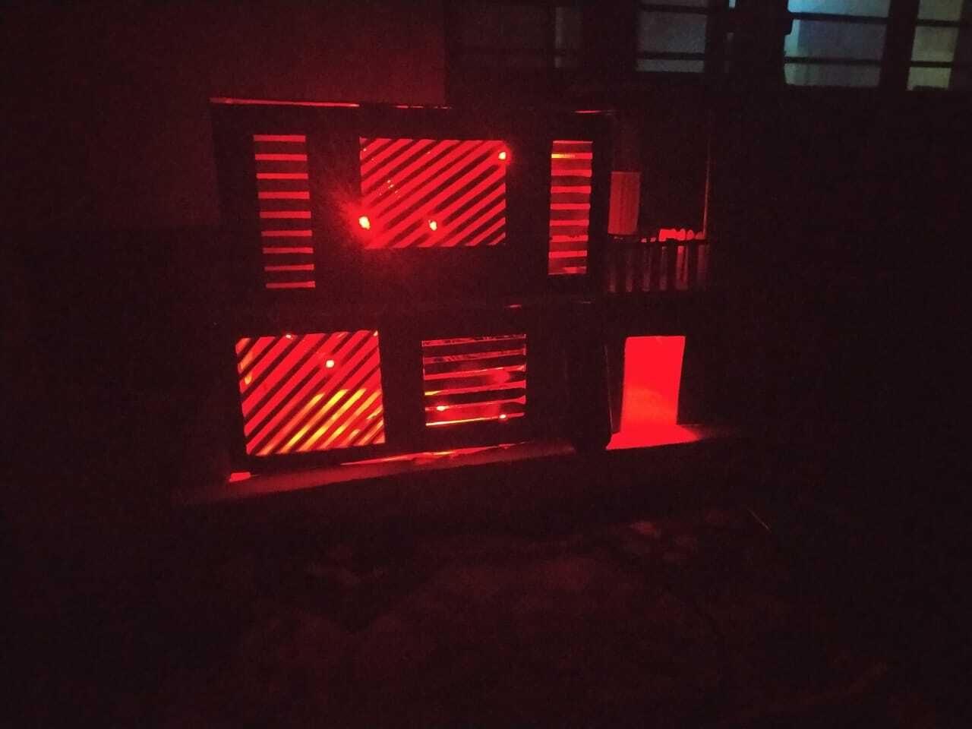

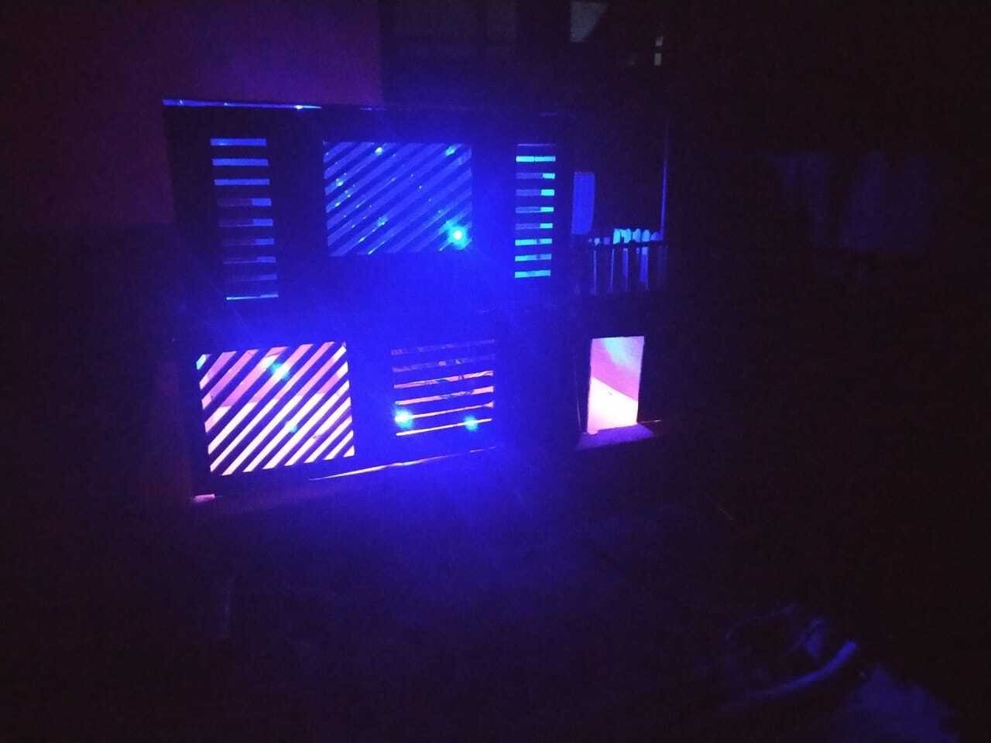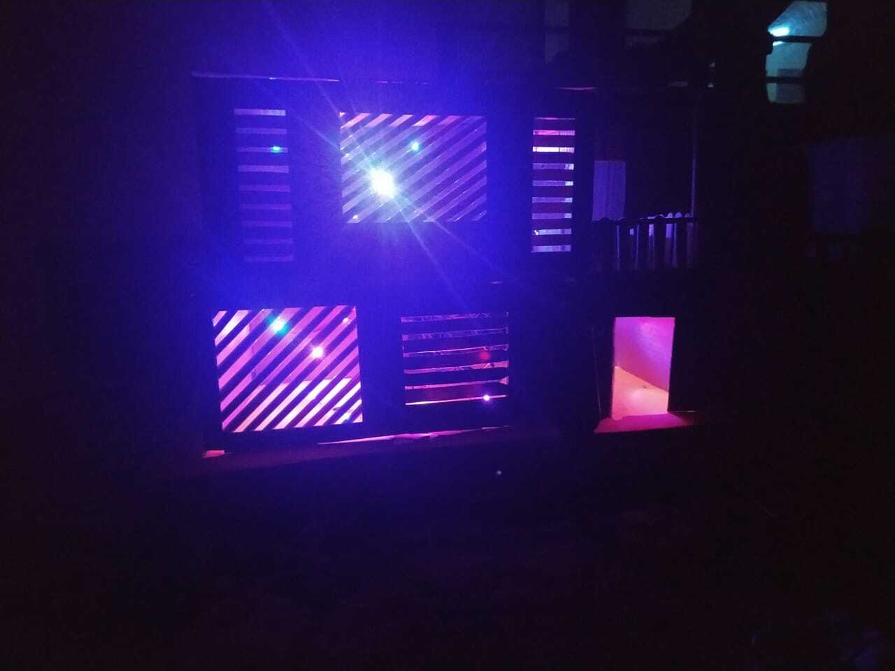

**4. MANUALLY DRIVEN MODULE:**

To this module all the modules are connected. So that we can also control all our devices manually too. Functionality of this module is that we can manually open and the close the windows and doors.

**5. TEMPERATURE MONITORING MODULE:**

In this module we have used a sensor named DHT-11. Through which we monitor the temperature of the home. It continuously send the data to our smart phone by using blynk cloud.

**6. AIR QUALITY MONITORING MODULE:**

In this module we have used the MQ-135 sensor for monitoring of air quality in the environment of the house.

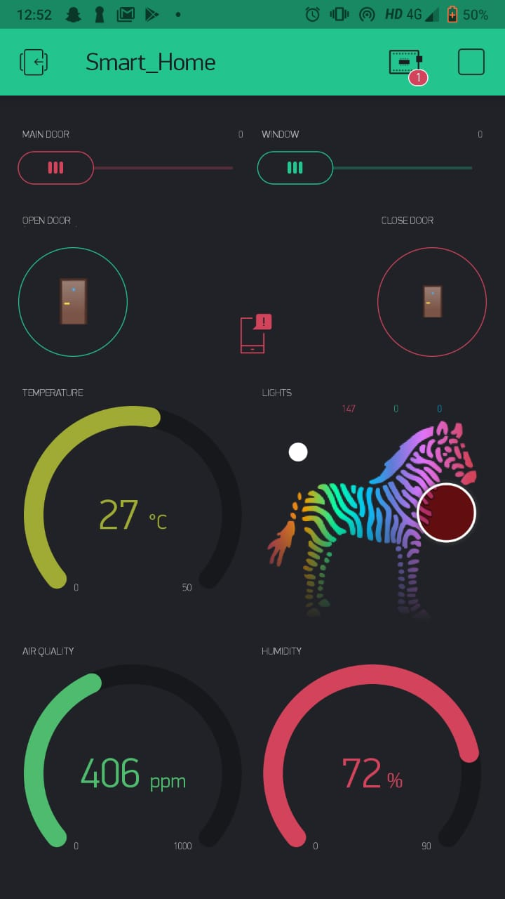

**CIRCUIT DIAGRAMS**

●**INTERFACING OF RAIN SENSOR WITH NODEMCU:**

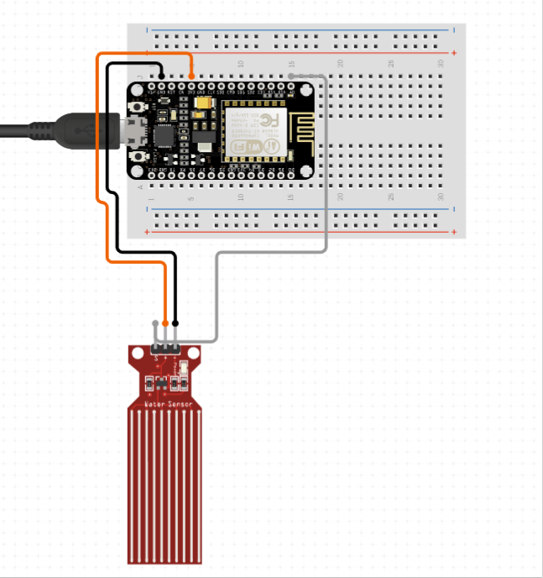

●**INTERFACING OF SERVO MOTOR WITH NODEMCU:**

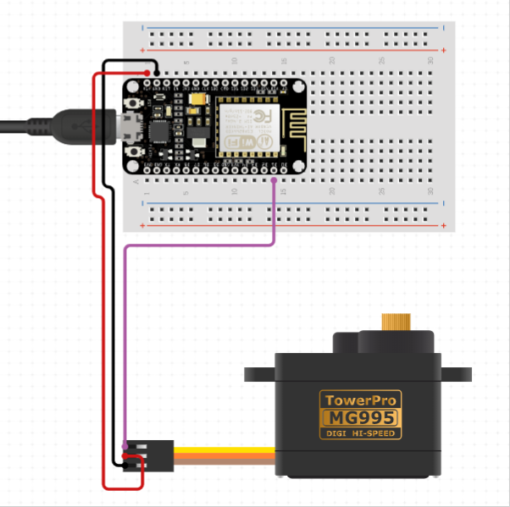

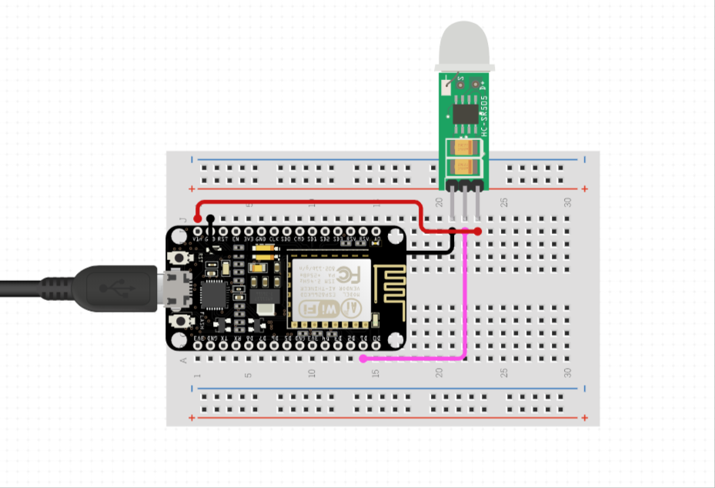●**INTERFACING OF PIR SENSOR WITH NODEMCU:**

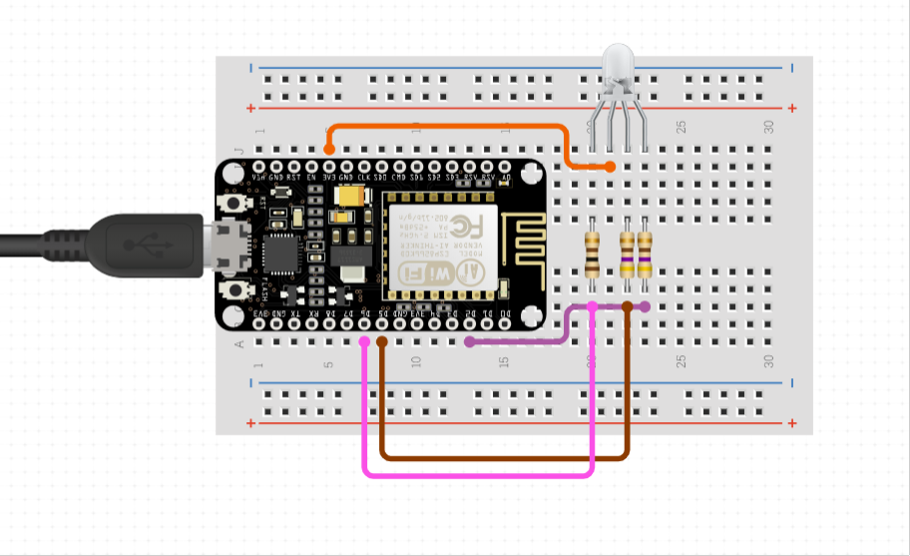●**INTERFACING OF RGB LED WITH NODEMCU:**

●**INTERFACING OF MQ-135 SENSOR WITH NODEMCU:**

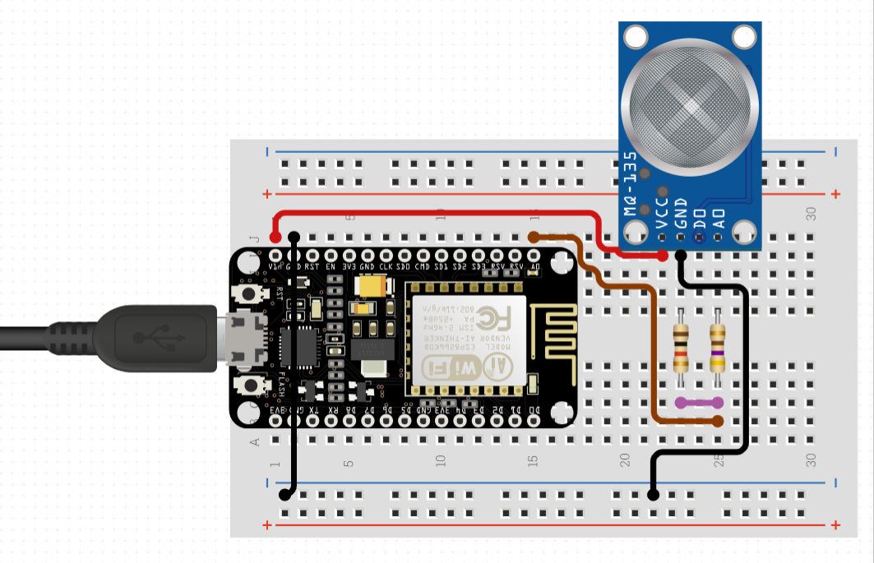

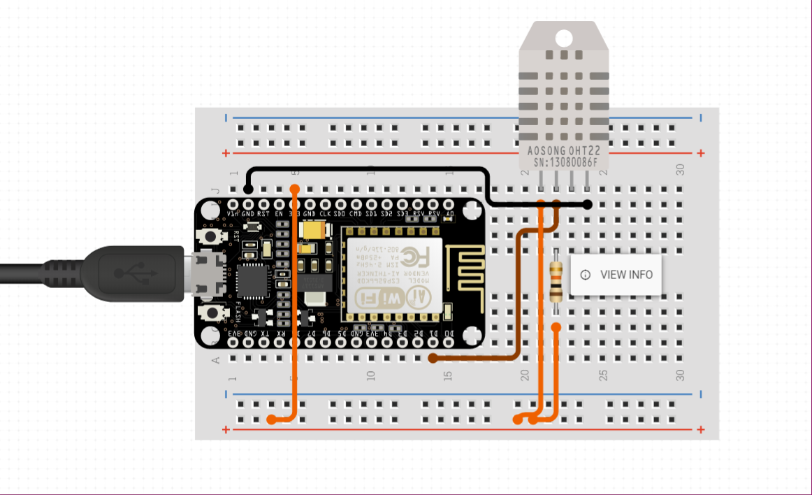●**INTERFACING OF DHT11 SENSOR WITH NODEMCU:**

**COMPLETE CIRCUIT DIAGRAM**

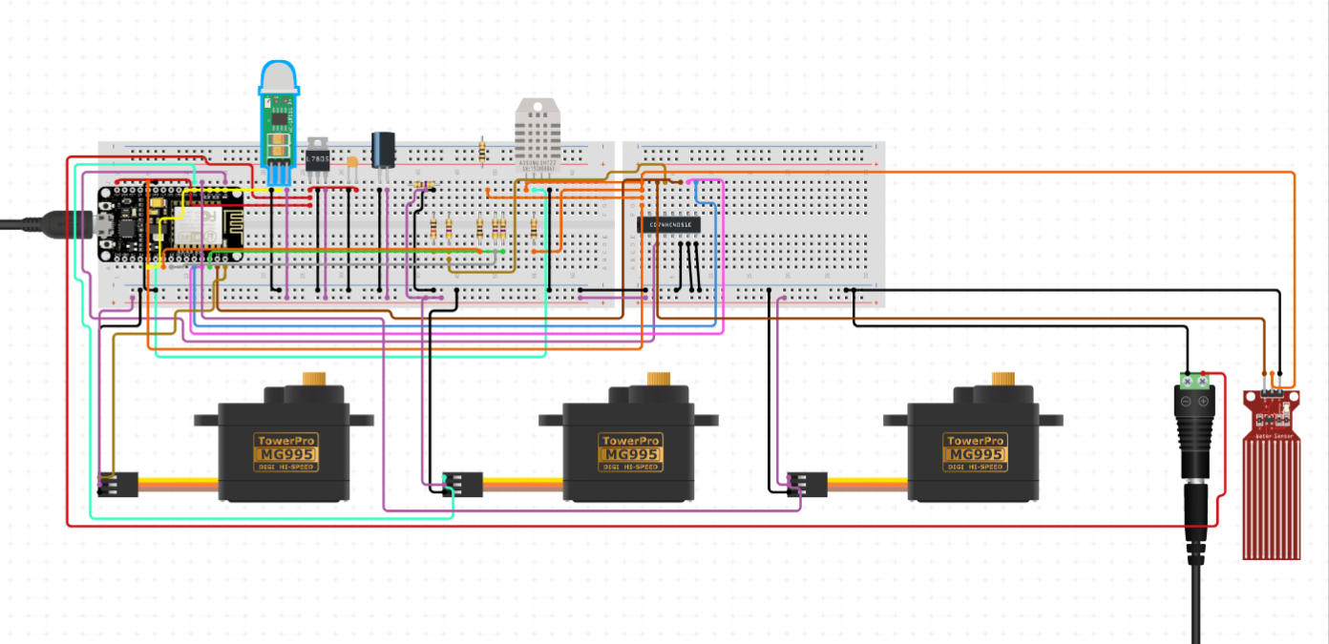

**SYSTEM TESTING**

●**INTRODUCTION**

System testing is done to find out if the proposed system is working as per our expectations or not? System testing has been done two steps.

●**TESTING METHODOLOGIES:**

Simple testing methodology is used for testing of system here. First of all code has been written for every module separately after that circuit has been completed for one module and testing has been performed for that module. After testing of every module separately, all the modules are combined together. After that again a testing of whole system is being performed. It has following steps.

●**UNIT TESTING:**

In this step of testing, all the modules are built and tested separately.

●**INTEGRATION TESTING:**

In this step of testing all the modules are combined together and testing of complete system is performed.

**SYSTEM IMPLEMENTATION**

●**PERPOSE:**

System implementation is the important stage of project when the theoretical design is tuned into practical system. The main stages in the implementation are as follows:

● Planning

● Training

● System testing and

● Changeover Planning

Planning is the first task in the system implementation. At the time of implementation of any system people from different departments and system analysts involve. They are confirmed to practical problem of controlling various activities of people outside their own data processing departments.

**APPENDICES**

●**PROGRAM LISTING:**

#define BLYNK_PRINT Serial

#include <ESP8266WiFi.h>

#include <BlynkSimpleEsp8266.h>

#include <DHT.h>

#include <Servo.h>

char auth[] = "ENbIz0CY_RbX7uxJhqPGklNv3wv9OOkP";

char ssid[] = "aman_thakur";

char pass[] = "123456";

#define RedPin D0

#define GrnPin D1

#define BluPin D2

#define pirpin D8

#define Grove_Water_Sensor D3

#define zeRGBa V0

#define mq1pin A0

int value=0;

int servoPin = D5;

int doorpin=D6;

int doorpin1=D7;

int rrr, ggg, bbb;

Servo servo;

Servo door;

Servo door1;

#define DHTPIN D4

#define DHTTYPE DHT11

DHT dht(DHTPIN, DHTTYPE);

BlynkTimer timer;

void senddata()

{

value = analogRead(mq1pin);

Blynk.virtualWrite(V15,value);

}

BLYNK_WRITE(V7)

{

servo.write(param.asInt());

}

BLYNK_WRITE(V8)

{

door.write(0);

}

BLYNK_WRITE(V9)

{

door.write(90);

}

BLYNK_WRITE(V10)

{

door1.write(param.asInt());

}

BlynkTimer timer1;

void myTimerEvent()

{

bool state=digitalRead(pirpin);

if(state==HIGH)

{

Serial.println("detected");

Blynk.notify("koi aya hai bro. !!!!!!!");

}

else

{

Serial.println("kuch nhi hai");

}

}

BLYNK_WRITE(zeRGBa)

{

rrr = param[0].asInt();

ggg = param[1].asInt();

bbb = param[2].asInt();

RGBprocess();

}

void RGBprocess()

{

analogWrite(RedPin, (255 - rrr) * 4 + 4);

analogWrite(GrnPin, (255 - ggg) * 4 + 4);

analogWrite(BluPin, (255 - bbb) * 4 + 4);

}

BlynkTimer timer2;

void senddhtdata()

{

int h = dht.readHumidity();

int t = dht.readTemperature();

if (isnan(h) || isnan(t))

{

Serial.println("Failed to read from DHT sensor!");

return;}Blynk.virtualWrite(V1 ,h);

Blynk.virtualWrite(V2 ,t);

}

void setup() {

Serial.begin(9600);

Blynk.begin(auth, ssid, pass);

pinMode(RedPin, OUTPUT);

pinMode(mq1pin,INPUT);

pinMode(GrnPin, OUTPUT);

pinMode(BluPin, OUTPUT);

pinMode(pirpin,INPUT);

servo.write(0);

door.write(0);

door1.write(0);

timer2.setInterval(1000L ,senddhtdata);

dht.begin();

timer1.setInterval(1000L, myTimerEvent);

timer.setInterval(1000L ,senddata);

servo.attach(servoPin);

door.attach(doorpin);

door1.attach(doorpin1);

}

void loop() {

Blynk.run();

timer1.run();

timer.run();

timer2.run();

if( digitalRead(Grove_Water_Sensor) == 0 ) {

servo.write(0);

delay(2000);

}}**DESCRIPTION OF FUNCTIONS:**

●**senddata():**

This function is taking no arguments. It is just reading the input from MQ-135 sensor and sending the data to the BLYNK cloud via a virtual pin V15.

●**myTimerEvent():**

This function is also taking no parameters. It is reading the output from PIR sensor and if it receives the input as HIGH, it sends an alert notification to BLYNK cloud.

●**senddhtdata():**

This function is just reading the output(Temperature, Humidity) from DHT11 sensor and sending the data to the BLYNK cloud through virtual pins(V1, V2).

●**RGBprocess():**

This function is just writing the data on red, blue and green virtual pins.

●**setup():**

In this function first we are starting the serial monitoring by setting up the baud rate to 9600. Then we arestarting our connection to the BLYNK cloud by using a keyword Blynk.begin() and in this we pass three parameters auth, ssid, pass. After that we are setting the mode of pins by using a keyword pinMode. Then we are attaching the servo pins to the servo objects. Then we are setting the intervals value for the functions.

●**loop():**

In this function we are first running the Blynk which makes necessary routines for communication with BLYNK server. Then we are executing the timers that we are defined with functions. After that we have written a condition which means if rain sensor detects rainfall then windows will automatically closed.

**APPLICATIONS OF THE PROJECT:**

● In this project we have used an motion detection sensor, which will provide you status of our main door. When anyone arrives at your door a notification will come on your smart phone.

● Second thing that we have used in this project is an air quality sensor that will provide you the quality of the air in ppm. Which will be very helpful in a real world house.

● We have used servo motors in every door and window. So that we can manually open and close the doors and windows. In real world we can use actuators in place of servo motors.

● We have also used DHT11 sensor which gives us the real time status of humidity and temperature of your home.

● We have used a rain sensor. When rain sensor detects the rainfall. Windows will automatically closed. So that the water will not come into your house through windows.

● RGB led are used in this project. Because of this we can control the colour of lights in our house.

**BIBLIOGRAPHY**

**● BOOK REFERENCES:**

1. Programming Arduino Getting Started with Sketches **SIMON MONK**

● **WEBSITES:**

1. [https://blynk.cc](https://blynk.cc/)

2. <https://www.nodemcu.com/index_en.html>

3. <https://en.wikipedia.org/wiki/Passive_infrared_sensor>

4. <https://en.wikipedia.org/wiki/Rain_sensor>

5. <https://circuitdigest.com/article/servo-motor-basics>

6. <https://www.waveshare.com/wiki/DHT11_Temperature-Humidity_Sensor>